Flight Booking system

10/09/2025

Case Study Description

Problem
• In today’s world, flight ticket booking is a complex process that involves checking flight availability, reserving seats, storing passenger details, and processing payments. Traditionally, this process was manual and prone to errors such as double-booking, incorrect passenger details, and lack of real-time updates.

Objectives
• The objective of the Flight Reservation System is to automate the booking process using Object-Oriented Programming (OOP) in C++. The system allows passengers to search available flights, book seats, and make payments, while administrators can manage flights and view reservations. The project ensures efficient data handling, data security (encapsulation), reusability (inheritance), flexibility (polymorphism), and abstraction of complex processes such as payments.

Main Classes, Attributes, and Methods

Flight
- Attributes: flightID, source, destination, totalSeats, bookedSeats, departureTime
- Methods: displayDetails(), checkAvailability(), bookSeat(), cancelSeat() Passenger
- Attributes: passportNo, age
- Methods: displayRole() (override), viewFlights(), makeReservation() Reservation
- Attributes: reservationID, passengerName, flightID, seatNumber
- Methods: confirmBooking(), cancelBooking(), showTicket()

OOP Concepts
- Encapsulation (Data Hiding): Passenger details (like passport number) and payment details are kept private.
- Inheritance (Reusability): Passenger and Admin inherit from User.
- Polymorphism (Flexibility): Overloaded methods for searchFlight() (by ID or route).
- Abstraction (Hiding Complexity): Payment is an abstract class with a pure virtual method processPayment().

UML Diagram
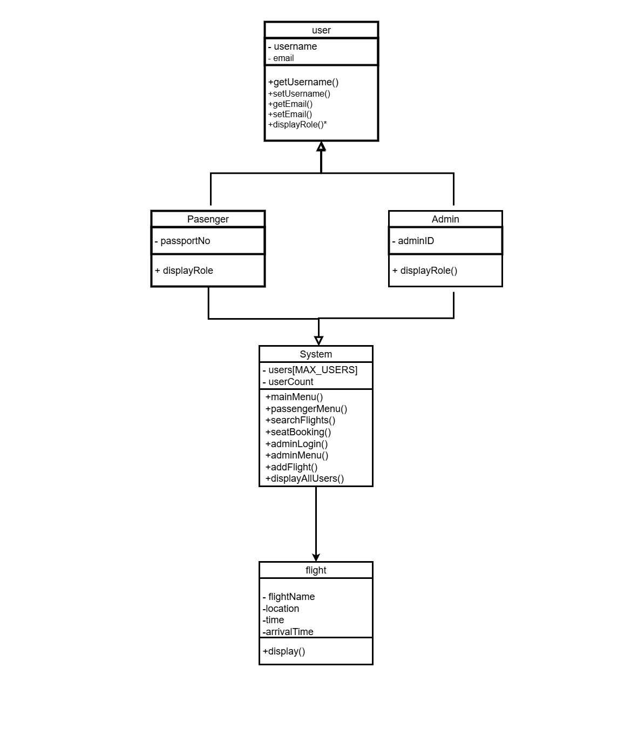

Code Implementation
#include <iostream>
#include <fstream>
#include <string>
#include <limits>
#include <algorithm>
#include <cctype>

using namespace std;
#define MAX_USERS 100 // Helper trim functions static inline void ltrim(string &s) {
s.erase(s.begin(), find_if(s.begin(), s.end(), [](unsigned char ch) { return !isspace(ch); }));
}
static inline void rtrim(string &s) {
s.erase(find_if(s.rbegin(), s.rend(), [](unsigned char ch) { return !isspace(ch); }).base(), s.end());
}
static inline void trim(string &s) { ltrim(s); rtrim(s);
}

// ================= Base User Class (Abstraction + Encapsulation)
=================
class User { protected:
string username, email; public:
User(string u, string e) : username(u), email(e) {} virtual void displayRole() const = 0; // Polymorphism string getUsername() const { return username; } void setUsername(string u) { username = u; } string getEmail() const { return email; } void setEmail(string e) { email = e; }
};
// ================= Passenger Class (Inheritance) =================
class Passenger : public User { private:
string passportNo; public:
Passenger(string u, string e, string p) : User(u, e), passportNo(p) {} void displayRole() const override { // Polymorphism
cout << "Passenger -> Name: " << username << ", Email: " << email << ", Passport: " << passportNo << endl;
}
};

// ================= Admin Class (Inheritance) =================
class Admin : public User { private:
int adminID;

public:
Admin(string u, string e, int id) : User(u, e), adminID(id) {}

void displayRole() const override { // Polymorphism cout << "Admin -> Name: " << username << ", Email: " << email
<< ", ID: " << adminID << endl;
}
};

// ================= Flight Class (Encapsulation) =================
class Flight { public:
string flightName, location, time, arrivalTime;

void display() {
cout << "Flight Name: " << flightName << endl; cout << "Location: " << location << endl;
cout << "Departure Time: " << time << endl; cout << "Arrival Time: " << arrivalTime << endl;
cout << "---------------------------\n";
}
};

// ================= System Class ================= class System { private:
User* users[MAX_USERS]; int userCount;

public:
System() : userCount(0) {}

// ---------- Main Menu ---------- void mainMenu() {
int choice; while (true) {
cout << "\n===== Flight Reservation Main Menu =====\n"; cout << "1. Passenger Panel\n"; cout << "2. Admin Panel\n"; cout << "3. Exit\n";
cout << "Enter choice: "; cin >> choice;

if (cin.fail()) { cin.clear();
cin.ignore(numeric_limits<streamsize>::max(), '\n'); cout << "Invalid input. Please enter a number.\n";
continue;
}

switch (choice) { case 1: passengerMenu(); break; case 2: adminLogin(); break;
case 3:
cout << "Exiting Program...\n";
return;
default: cout << "Invalid choice!\n";
}
}
}

// ---------- Passenger Panel ----------
void passengerMenu() {

int choice; while (true) { cout << "\n===== Passenger Panel =====\n"; cout << "1. Search Flights and Times\n"; cout << "2. Seat Booking\n"; cout << "3. Exit to Main Menu\n"; cout << "Enter choice: "; cin >> choice;

if (cin.fail()) { cin.clear();
cin.ignore(numeric_limits<streamsize>::max(), '\n'); cout << "Invalid input. Please enter a number.\n";
continue;
}

switch (choice) { case 1: searchFlights(); break; case 2: seatBooking(); break; case 3: return; default: cout << "Invalid choice!\n";
}
}
}

void searchFlights() { int choice; cout << "\n--- Search Flights ---\n"; cout << "1. Search by Location\n"; cout << "2. Show All Flights\n"; cout << "Enter choice: "; cin >> choice;

if (cin.fail()) { cin.clear();
cin.ignore(numeric_limits<streamsize>::max(), '\n'); cout << "Invalid input. Returning to passenger menu.\n";
return;
}

ifstream fin("flights_data.txt");
if (!fin) {
cout << "No flights available (flights_data.txt missing).\n";
return;
}

Flight f; string searchLocation;
if (choice == 1) { cout << "Enter Location: "; cin.ignore(numeric_limits<streamsize>::max(), '\n'); getline(cin, searchLocation); trim(searchLocation);
} else {
// flush newline if needed
cin.ignore(numeric_limits<streamsize>::max(), '\n');
}

cout << "\n--- Flight List ---\n"; while (getline(fin, f.flightName) && getline(fin, f.location) && getline(fin, f.time) && getline(fin, f.arrivalTime)) {
if (choice == 2 || (choice == 1 && f.location.find(searchLocation) != string::npos)) {
f.display();
}
}
fin.close();
}

void seatBooking() { string fullName, email, flight, seatClass;

cin.ignore(numeric_limits<streamsize>::max(), '\n'); cout << "Enter Full Name: "; getline(cin, fullName); trim(fullName); cout << "Enter Email Address: "; getline(cin, email); trim(email); cout << "Enter Flight Name: "; getline(cin, flight); trim(flight);
cout << "Enter Seat Class (1st class / 2nd class): "; getline(cin, seatClass); trim(seatClass);

cout << "\nSeat booking is complete!\n"; cout << "Booking Details:\n"; cout << "Name: " << fullName << "\nEmail: " << email
<< "\nFlight: " << flight << "\nClass: " << seatClass << endl; // Add passenger into system list (guard against overflow) if (userCount < MAX_USERS) { users[userCount++] = new Passenger(fullName, email, "N/A");
} else {
cout << "Cannot add passenger to internal list: maximum users reached.\n";
}
}

// ---------- Admin Panel ---------- void adminLogin() { string name, password, email;
string idInput; int userID = -1;

// safe flush and read lines
cin.ignore(numeric_limits<streamsize>::max(), '\n'); cout << "Enter Admin Name: "; getline(cin, name); trim(name);

cout << "Enter Email: "; getline(cin, email); trim(email);

cout << "Enter User ID: "; getline(cin, idInput); trim(idInput);

// validate numeric ID if (idInput.empty() || !all_of(idInput.begin(), idInput.end(), ::isdigit)) { cout << "Invalid User ID. Please enter numeric ID only.\n"; return; // return to main menu
}
try {
userID = stoi(idInput);
} catch (...) {
cout << "Invalid User ID. Please try again.\n";
return;
}

cout << "Enter Password: "; getline(cin, password); trim(password);

// simple password check (for demo)
if (password == "admin123") {
cout << "Welcome to Admin Panel!\n"; if (userCount < MAX_USERS) {
users[userCount++] = new Admin(name, email, userID);
} else {
cout << "Warning: cannot store admin in memory: users array full.\n";
}
adminMenu();
} else {
cout << "Invalid login!\n";
}
}

void adminMenu() {
int choice; while (true) {
cout << "\n===== Admin Menu =====\n";
cout << "1. Add Flight\n"; cout << "2. Display All Users\n"; cout << "3. Exit to Main Menu\n"; cout << "Enter choice: "; cin >> choice;

if (cin.fail()) { cin.clear();
cin.ignore(numeric_limits<streamsize>::max(), '\n'); cout << "Invalid input. Please enter a number.\n";
continue;
}
switch (choice) { case 1: addFlight(); break; case 2: displayAllUsers(); break; case 3: return;
default: cout << "Invalid choice!\n";
}
}
}

void addFlight() { Flight f;
cin.ignore(numeric_limits<streamsize>::max(), '\n'); cout << "Enter Flight Name: "; getline(cin, f.flightName); trim(f.flightName); cout << "Enter Location: "; getline(cin, f.location);
trim(f.location);
cout << "Enter Departure Time: ";
getline(cin, f.time); trim(f.time); cout << "Enter Arrival Time: "; getline(cin, f.arrivalTime); trim(f.arrivalTime);
ofstream fout("flights_data.txt", ios::app);
if (!fout) {
cout << "Error opening file.\n"; return;
}

fout << f.flightName << endl; fout << f.location << endl; fout << f.time << endl; fout << f.arrivalTime << endl; fout.close();
cout << "Flight added successfully!\n";
}
// ---------- Display All Users (Polymorphism in Action) ---------- void displayAllUsers() { if (userCount == 0) {
cout << "No users available.\n";
return;
}
cout << "\n--- User List ---\n"; for (int i = 0; i < userCount; i++) { users[i]->displayRole(); // Polymorphism
}
}
};
// ================= Main =================
int main() { System sys; sys.mainMenu();
return 0;
}

Sample Input & Output

Ex :- Add Flight
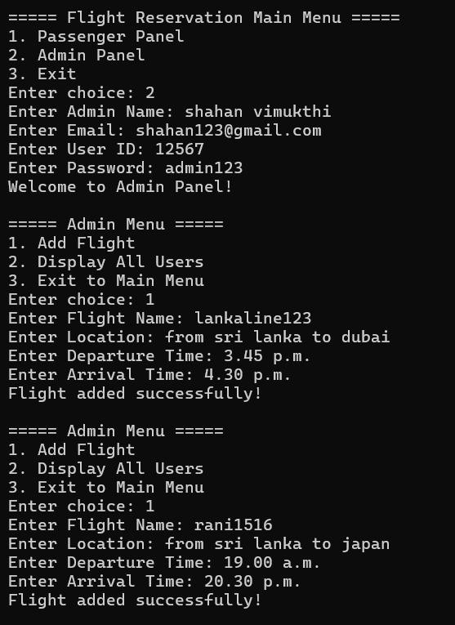

Ex :- Display Flight List
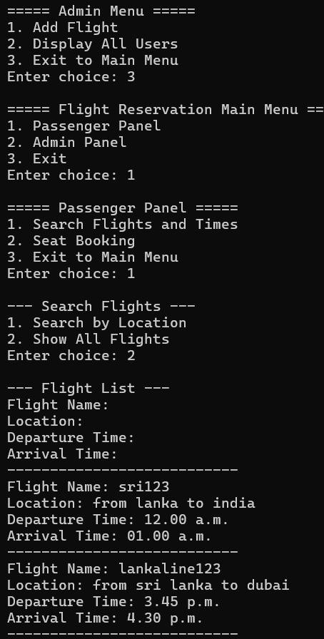

Ex :- Seat Booking
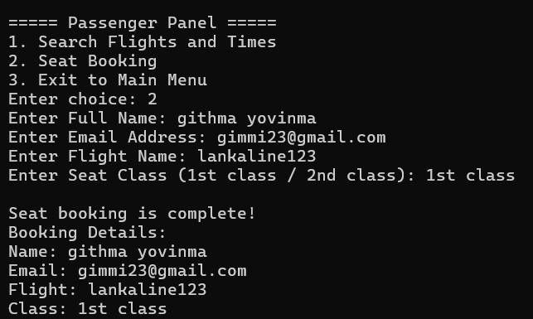

Ex :- Search Flight
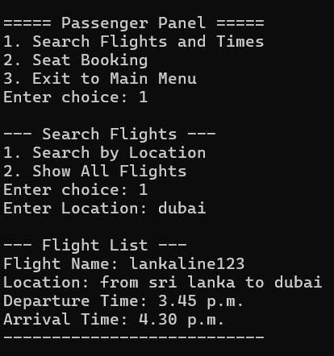

Ex :- User List
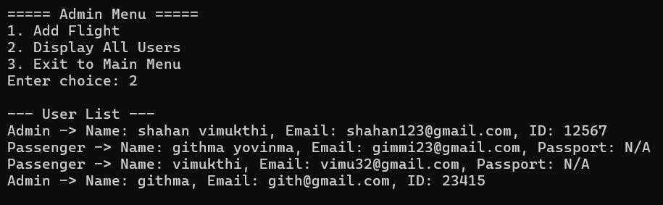
Ex :- Program Exit
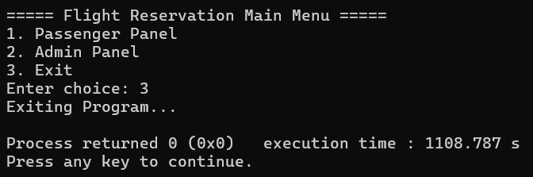

Flight Details (.txt)
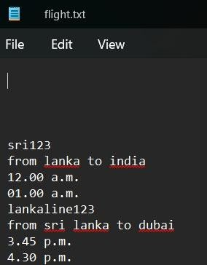

OOP Concept

1. Encapsulation
Encapsulation means data + methods are bundled in a class, and direct access to data is restricted using access specifiers (private, protected, public).
• Example:


protected:

string username, email; // cannot be accessed directly
from outside

→ Data is hidden, and access is only allowed through getters/setters:
class Passenger : public User { ... }; class Admin : public User { ... };

2. Inheritance
Inheritance allows one class to reuse properties/methods of another class.
• Example:
class Passenger : public User { ... }; class Admin : public User { ... };

→ Passenger and Admin inherit from User.
So both get username, email, getUsername(), etc., automatically.

3. Polymorphism
Polymorphism = “many forms.
- Run-time polymorphism (Virtual Functions & Overriding):
virtual void displayRole() const = 0; // abstract function in User

- Passenger overrides it:
void displayRole() const override { cout << "Passenger -> ..." << endl; }

- Admin overrides it:
void displayRole() const override { cout << "Admin -> ..." << endl; } When calling:
users[i]->displayRole();

→ Even though users[i] is of type User*, the correct version (Passenger/Admin) is executed at runtime.

4. Abstraction
Abstraction = hiding implementation details and showing only necessary features.
• Example: User class is an abstract class because it has a pure virtual function:
virtual void displayRole() const = 0;

→ You cannot create a User object directly, only Passenger or Admin.
→ This ensures all derived classes must implement displayRole().

